NUTRIENT CYCLES
(How are nutrients recycled through ecosystems?)

Why?
We have learned the importance of recycling our trash. It allows us to use something again for another purpose and prevents the loss of natural resources. But what happens to the waste in nature? Why aren’t we up to our necks in poop? Why is there always a supply of water? Why is there oxygen to breathe and carbon dioxide for photosynthesis? Organic compounds in nature are also recycled. This recycling process converts the complex organic compounds to simple, inorganic compounds, which then can be returned to the nutrient cycle and be used in nature again and again.

Model 1: The Carbon Cycle
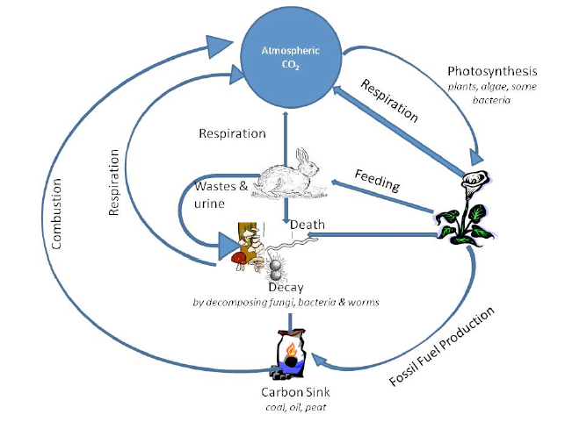
- Name two ways that carbon (usually in the form of CO₂) enters the atmosphere.
- What process uses CO₂ from the atmosphere?
- What organisms carry out that process?
- Wastes and dead organisms must be broken down in order for their components to be used again. What organisms in the cycle carry out this process?

- What would happen if decomposition did not occur?
- Not all dead organisms are acted by decomposers. Instead of being immediately recycled, the carbon from some organisms is kept in a type long-term storage, or carbon sink. Answer the questions below about this long-term storage.
  - List three materials that contain this stored carbon.
  - What is the collective term for these three materials?
  - How do modern humans use these carbon stores?
  - How does our use of these carbon stores affect the amount of CO₂ in the atmosphere?

Model 2: The Nitrogen Cycle
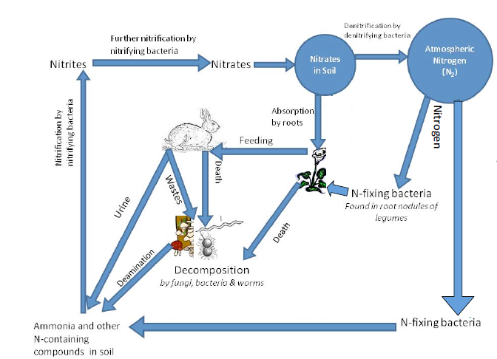

- In what ways is N₂ gas removed from the atmosphere?
- Name three types of bacteria involved in the nitrogen cycle.
- By what process are animal wastes, urine and dead organisms converted to other nitrogen containing compounds?

- What form of nitrogen do plants absorb from the soil?
- What do the denitrifying bacteria do?
- If the number of nitrifying bacteria decreased what effect would this have on the nitrogen cycle and what type of compounds would accumulate as a result?

Model 3: The Water Cycle

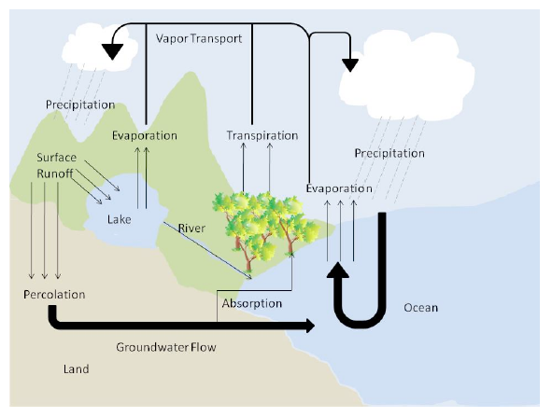
- What is the largest reservoir for water on earth?
- What process contributes to the formation of groundwater?
- Name two ways in which water is converted to vapor.
- How does water return to the oceans from the land?
- Rain, sleet and snow are examples of what?
- Which of the processes associated with the water cycle might be responsible for helping to clean or filter the water?

- If the air contains high levels of pollutants what effect might this have on water quality?

Extension Questions

- Which process(es) of the water cycle – precipitation, evaporations, condensation, run-off, percolation or transpiration might contribute to the addition of pollutants to rivers, lakes and oceans? Why?

- In order to continually use the same area of land for agriculture, some farmers apply fertilizers to improve the level of nitrates in the soil. An alternative to intensive use of fertilizer is to plow the roots of legume plants back into the soil and leave the area unplanted for a season. Why would a farmer plow this type of plant roots back into the soil and what would be the benefit of turning over the soil and leaving the old plant roots?

